CI/CD Deployment for SpringBoot Application.

Screenshot.

Screenshot

Version History:

|  |  |
| --- | --- |
| Author | Aman Kumar |
| Purpose | Project Screenshot |
| Date | 26/07/2022 |
| Version | 1.0 |

Configure Jenkins

* Download and install Jenkins in the local machine.
* Login to Jenkins using the address: **http://localhost:8080/**
* Create a new item in the Jenkins as in the below image:

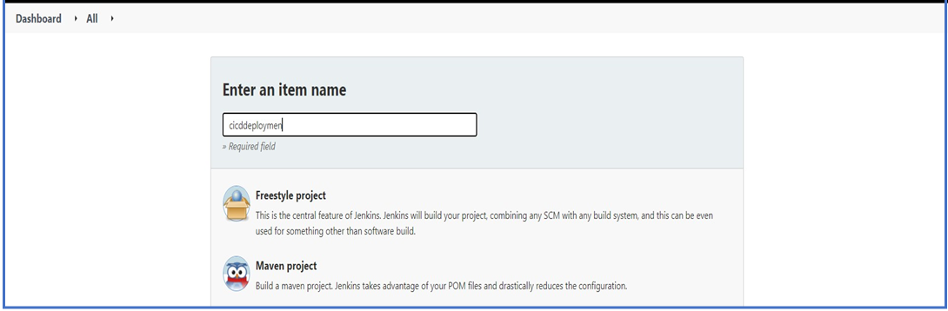

* Configure Jenkins by giving GitHub link and Docker credentials as in the below images:

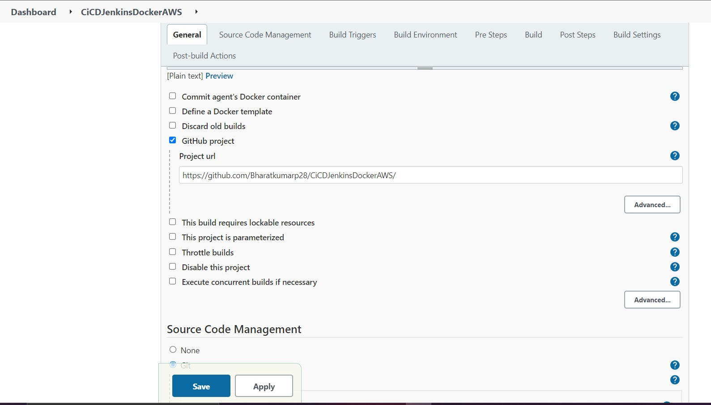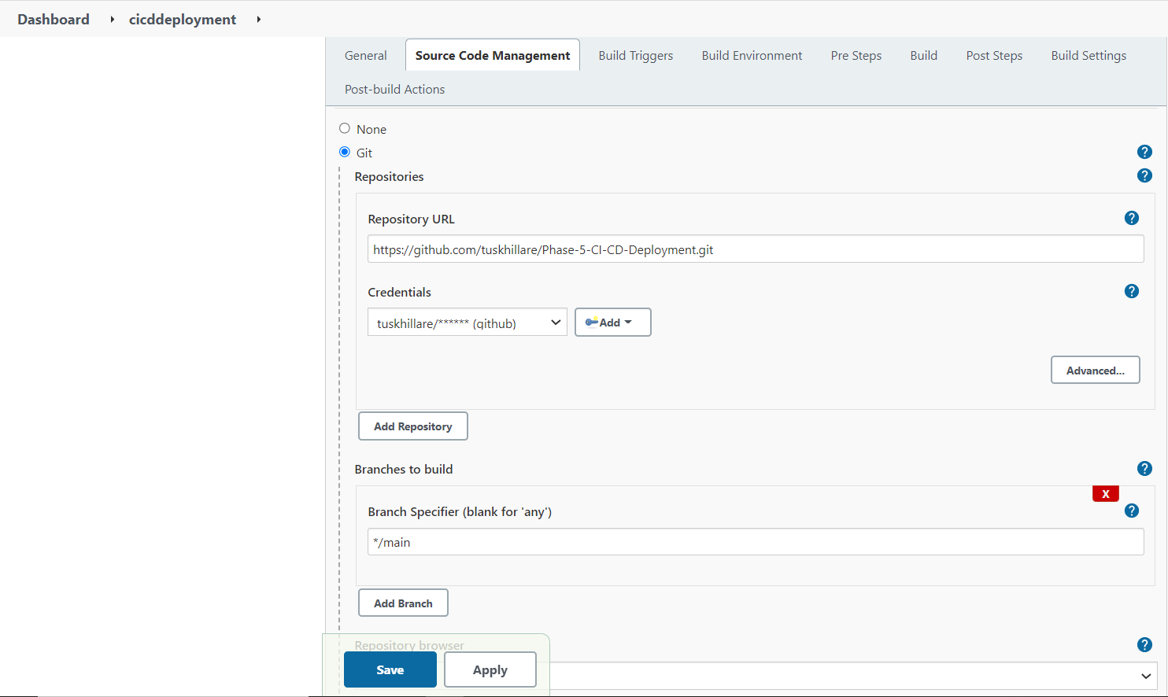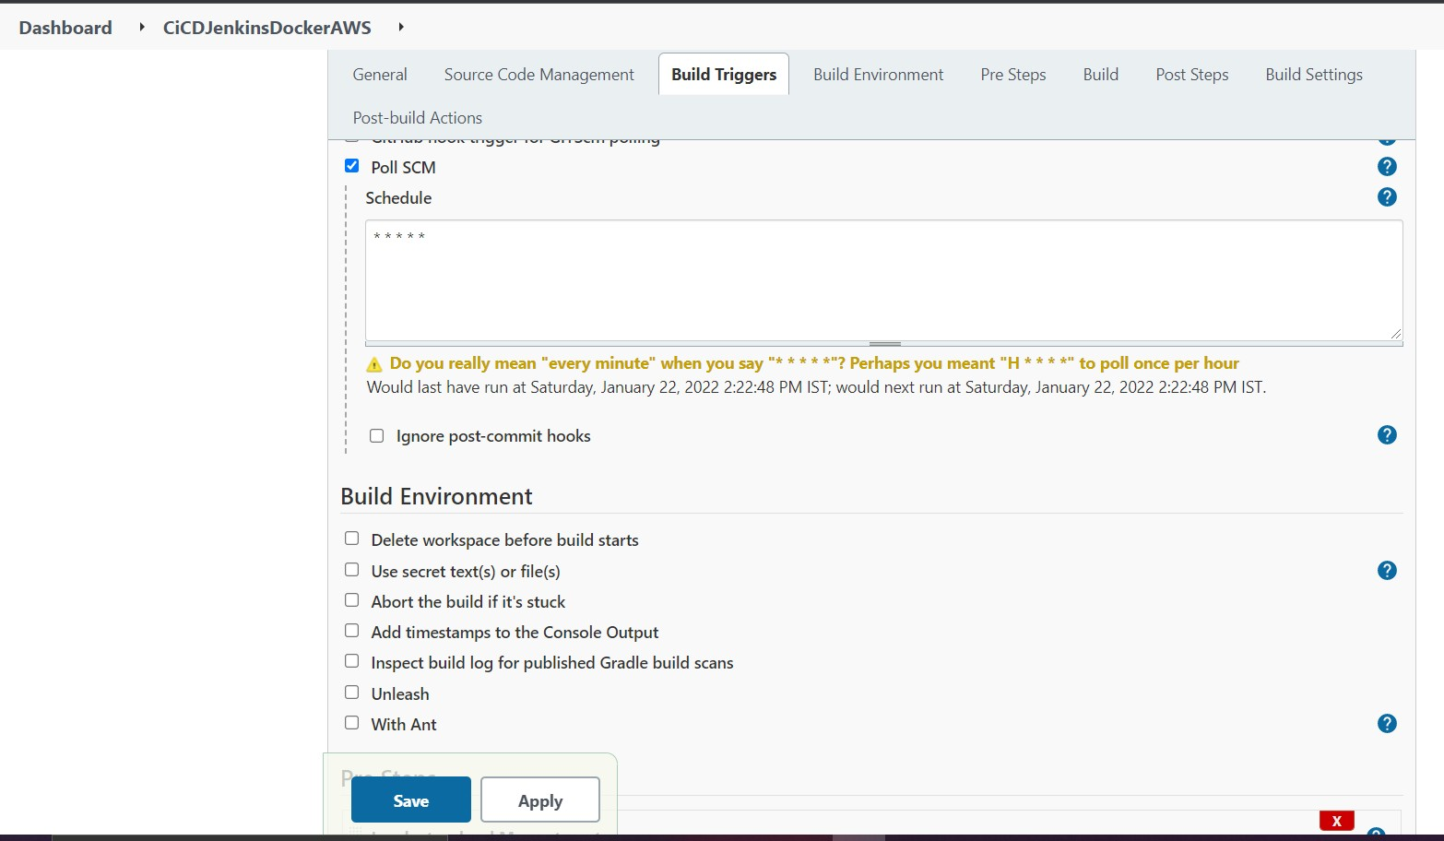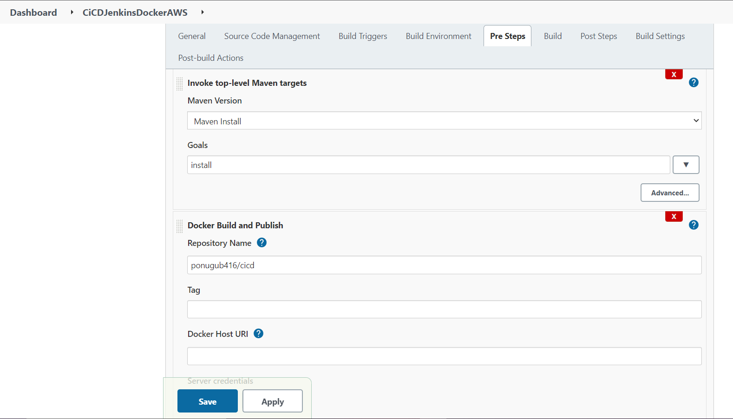

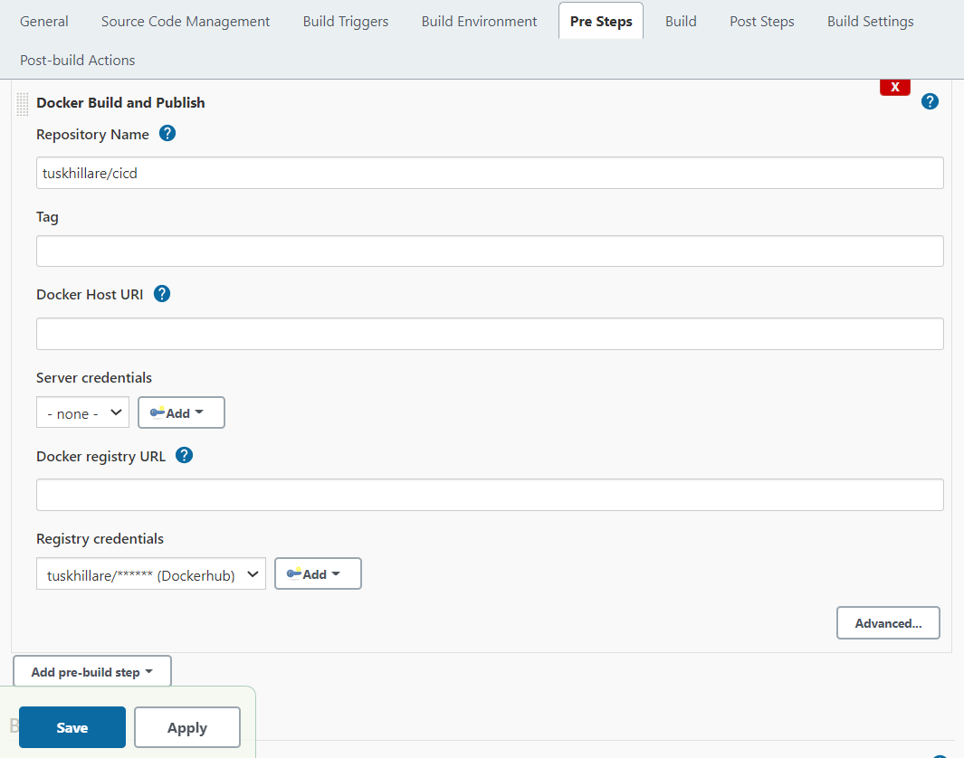

**Build Docker Image File**

* We have configured GitHub file with Docker File included and given the docker hub credential to initiate the docker image file.
* Once done with the configuration of Jenkins apply and save the configs and click on Build Now:

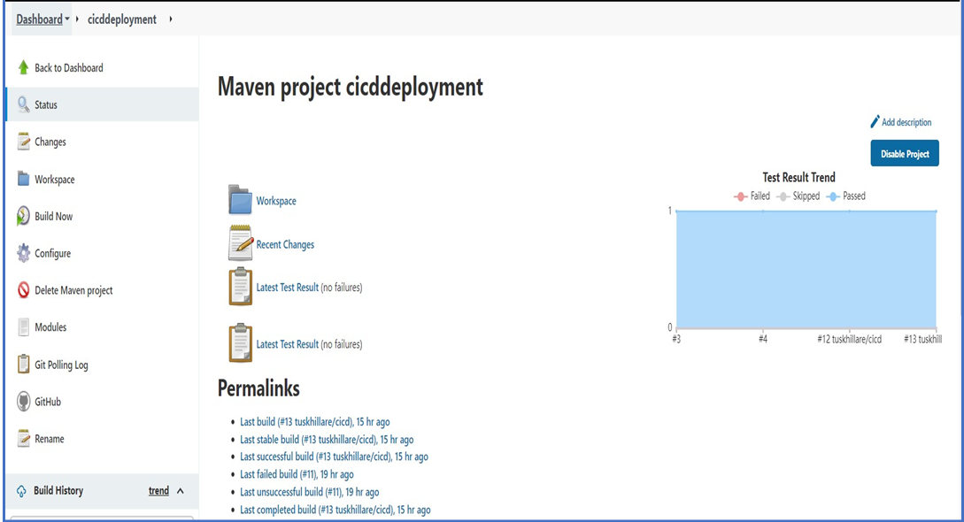

We can see the Build History in the Build history tab:

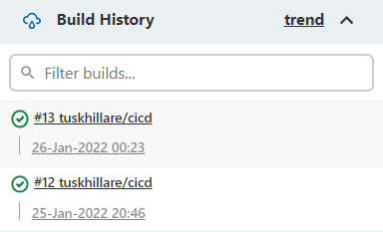

* Check the Console output for the any errors/ build completed log:

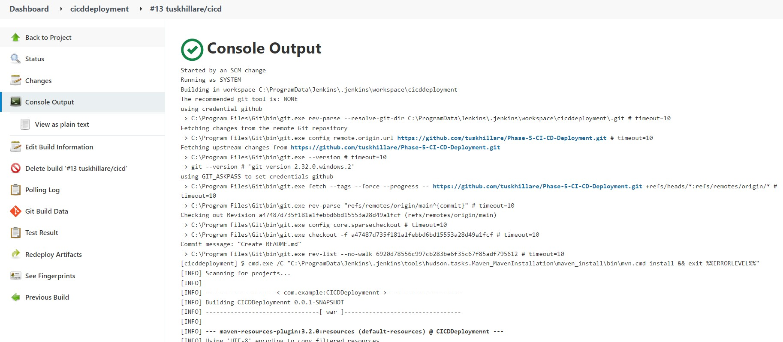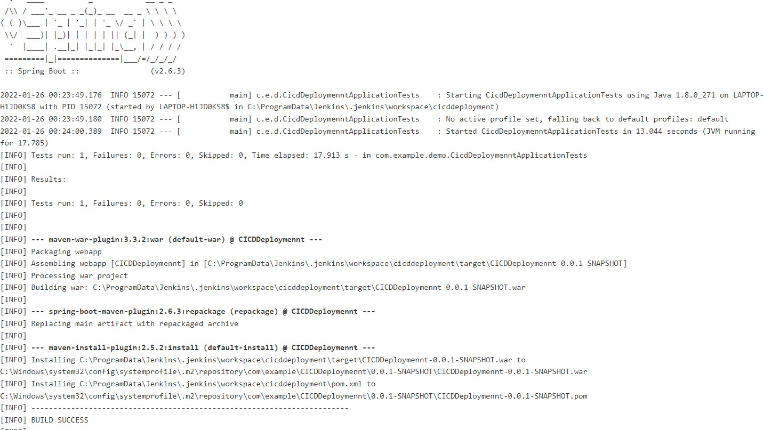

* Once the Build is completed login to Docker Hub (Desktop/URL) and see if the image has been created and pushed to the Docker hub as in the below image:

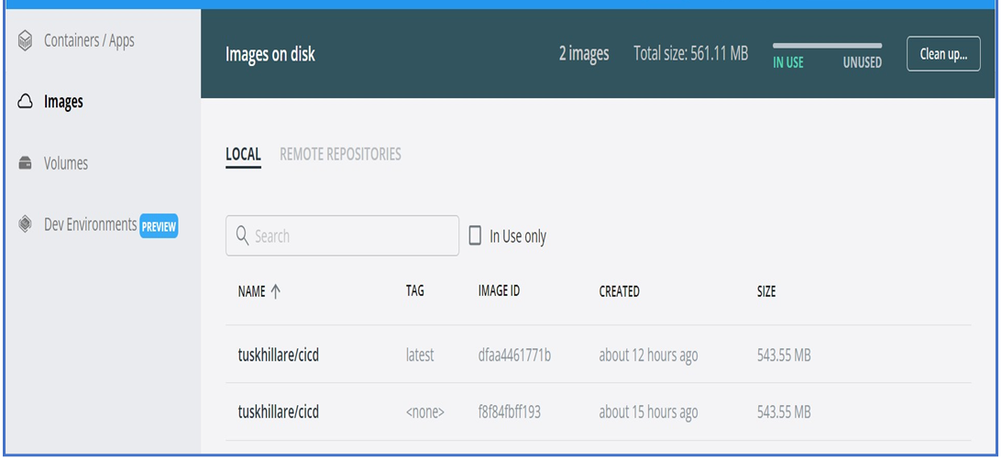

* 1. AWS EC2 instance and Deploy
* Login to Amazon AWS and choose to launch a new instance by selecting the Amazon Machine Image (AMI)

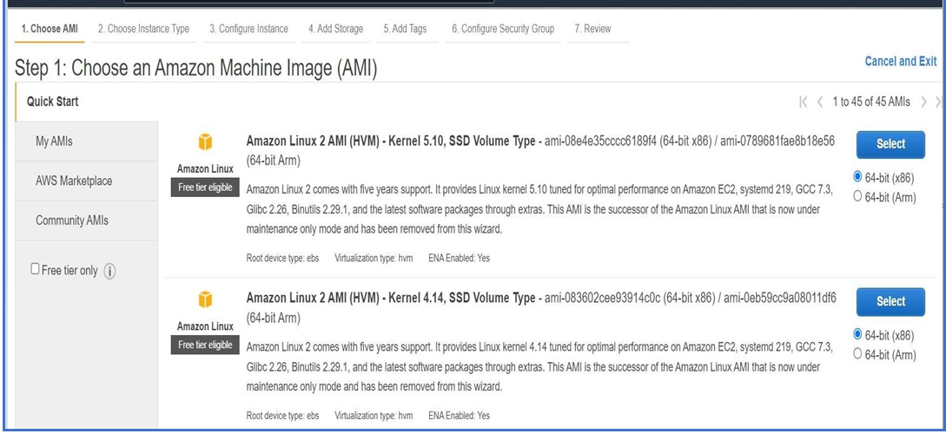

* After selecting the AMI do the configuration as in the below images:

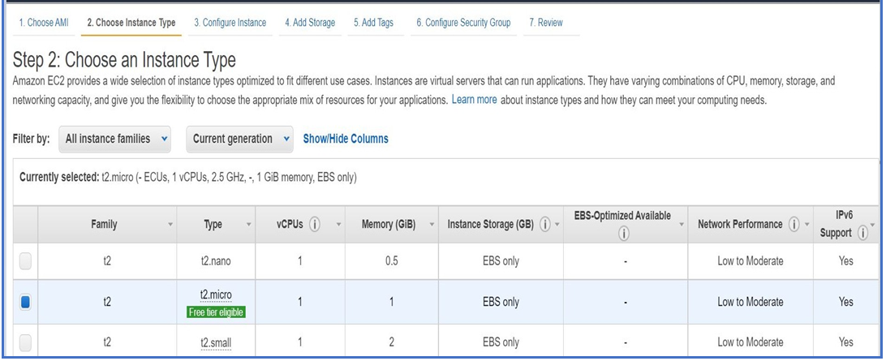

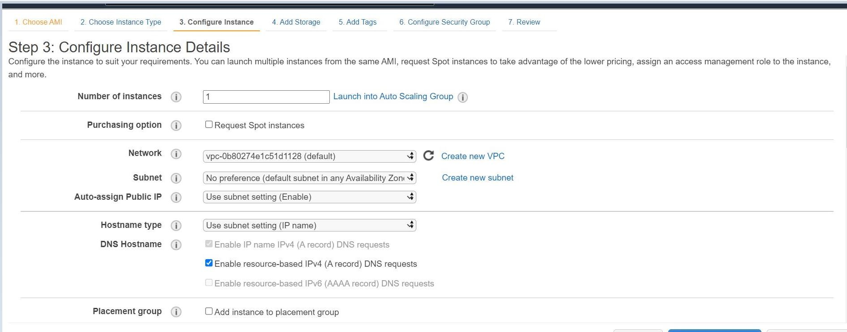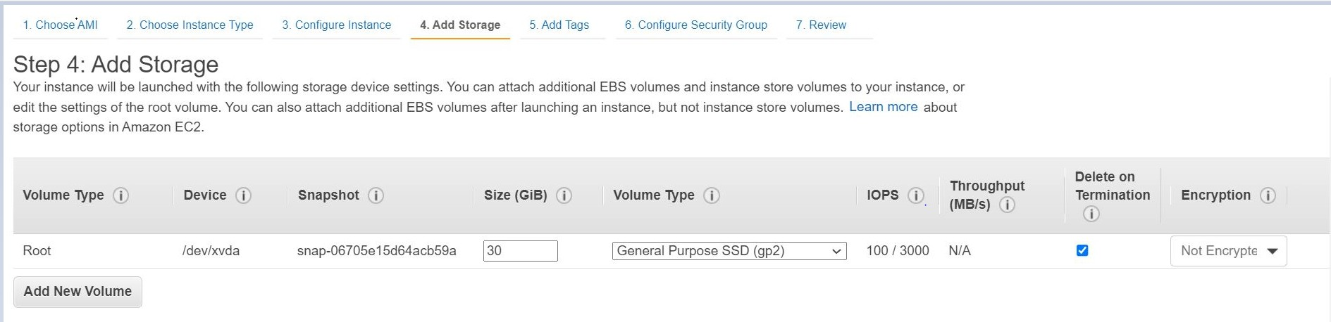

Ensure that you have configure Security group so that we are able to do the inbounds and outbounds rules to access our spring boot application using the public IP address as in the below image:

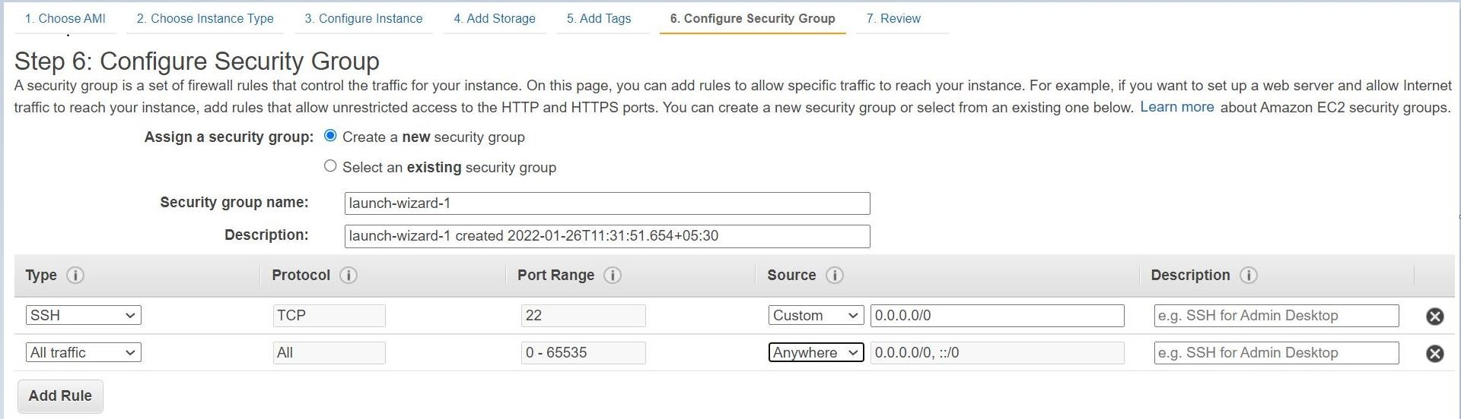

Once done with the configuration review and launch the instance

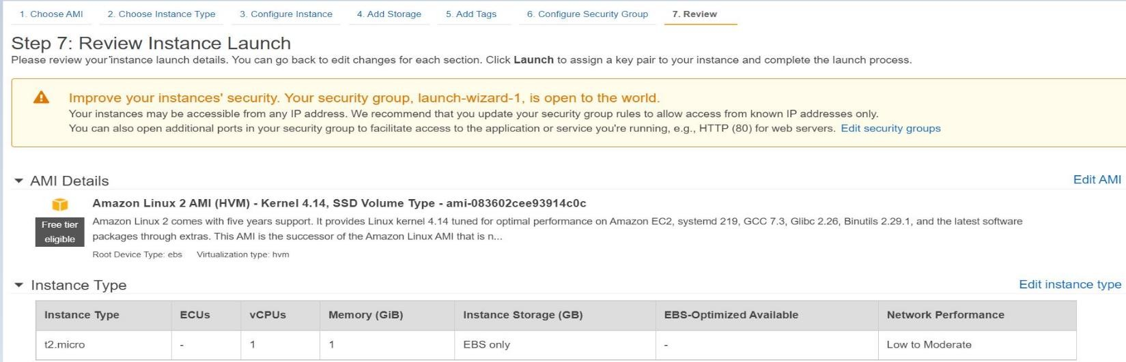

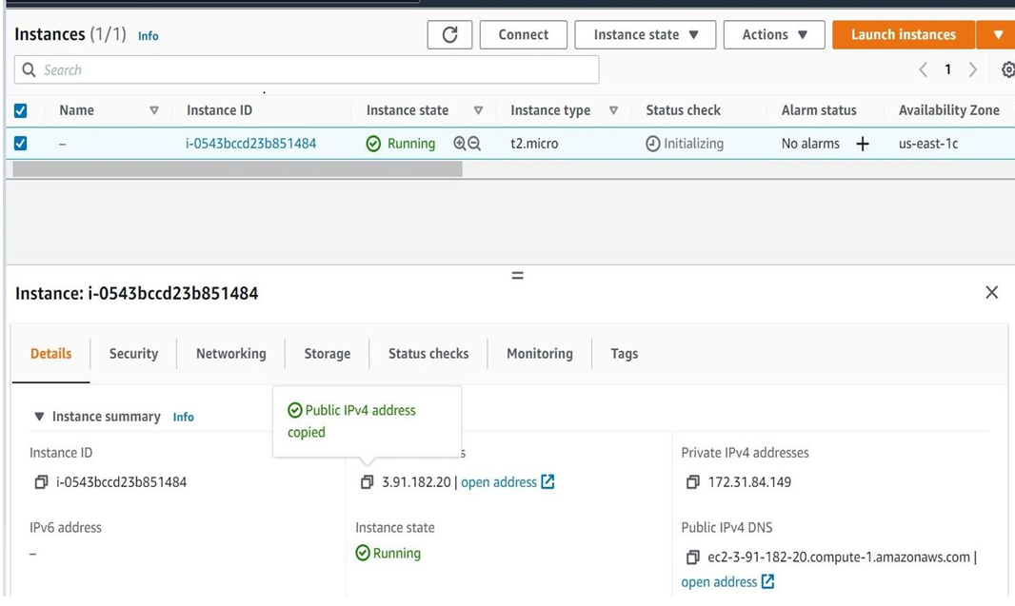

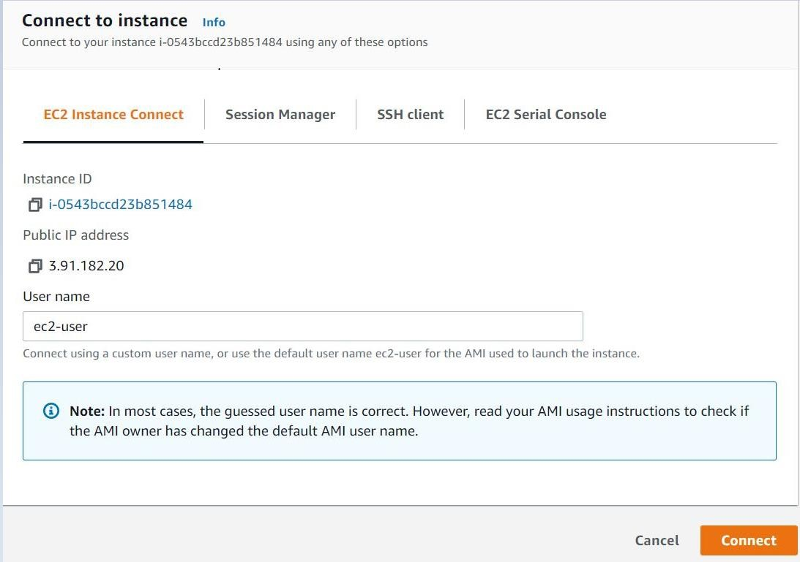

* It will Open the AWS instance as in the below image:

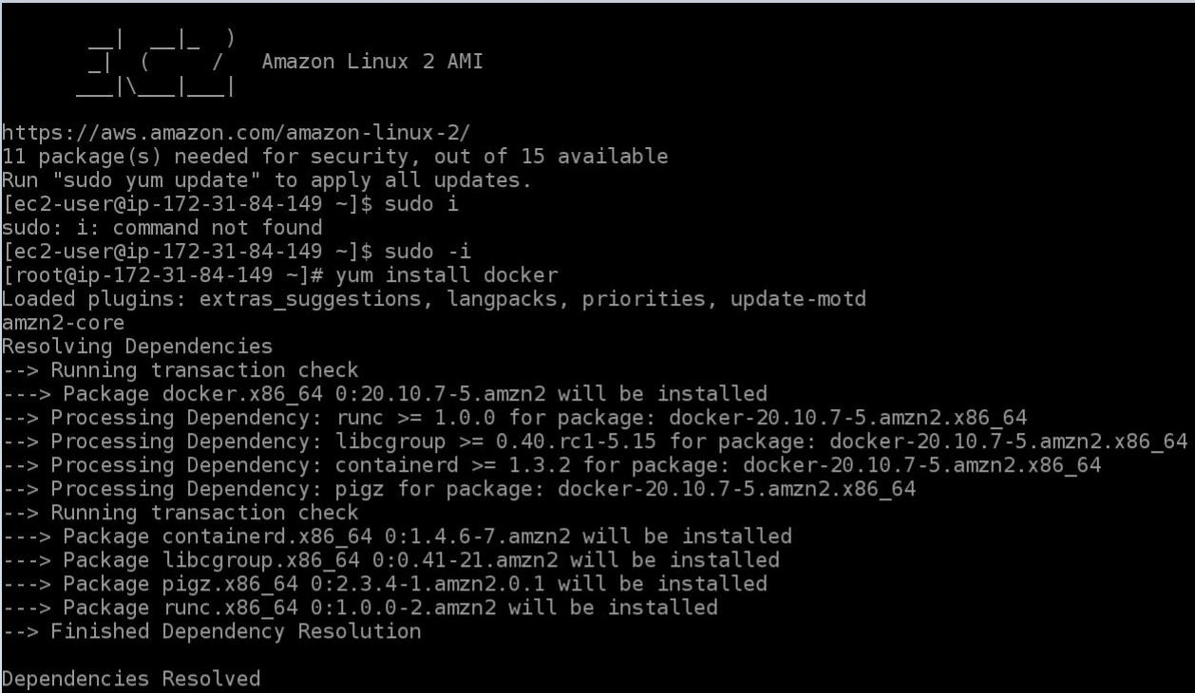

**Here we have gone through the flow by the following steps:**

* Programming Spring boot application with a docker file.
* Pushing the project into the GitHub.
* Configure Jenkins to have GitHub project as input and Docker Hub as output and by building the WAR file and converting it into the Docker image and pushing into the Docker Hub.
* Configure the AWS ECS and connecting it through Putty.
* Deploying and hosting the docker file on the AWS EC2 instance using the demon command.
* We can access our Spring boot application from anywhere using he Public Ip address in my case which is: <http://3.91.182.20:7000/>